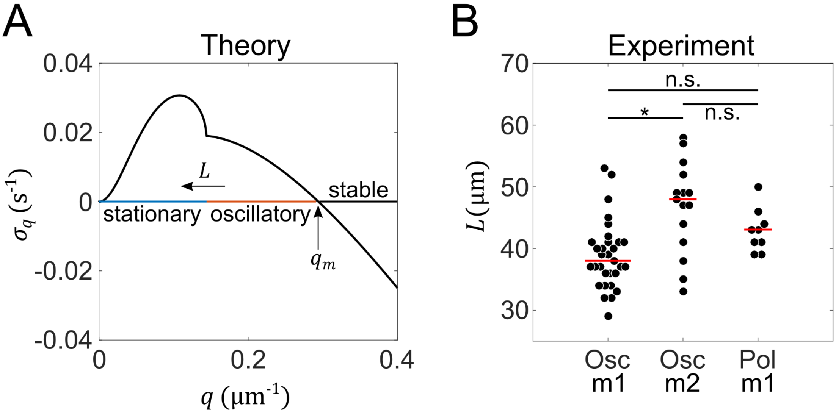

**S5 Fig. Effect of circumference size on pattern formation.** (**A**) The growth rate has positive values for wavenumbers within the interval $(0,q_{m})$, implying that these modes are unstable. Since the wavenumber is a function of $L$, represented as $q=2nπ/L$, the value $q_{m}$ defines the minimum length, $L_{n}^{min}=2nπ/q_{m}$, at which the $n^{th}$ Fourier mode becomes unstable. Using the parameter values in S2 Appendix Table 1, we have determined $L_{1}^{min}\sim 20 μm$, $L_{2}^{min}\sim 40 μm$, and so on. As $L$ increases (which means $q$ decreases), the type of instability changes from oscillatory to stationary, as indicated by the kink in the growth curve. For all $L>L_{1}^{min}$, however, the result of the simulations is an oscillating pattern. (**B**) A comparison of the measured perimeters of cells showing first-order oscillatory patterns (Osc m1), second-order oscillatory patterns (Osc m2), and first-order stationary patterns (Pol m1). The red lines denote the respective median values: $L\left(Osc_m1\right)=38 \left(36 to 41\right) μm$, $n=31$; $L\left(Osc_m2\right)=48 \left(42 to 51\right) μm$, $n=15$; $L\left(Pol_m1\right)=43 \left(40 to 45\right) μm$, $n=9$, (median, interquartile range); * means $P<0.01$, while n.s. means not significant.